Ecological uniqueness of South American Andean diatoms across space and time

Xavier Benito1*, Annika Vilmi2, Melina Feitl3, Marja Lindholm4, Maria-Laura Carrevedo5, Sherilyn C Fritz3

1SESYNC, University of Maryland

2Add your affiliation as corresponds

3

4

**\* Correspondence:**Corresponding Author  
xbenitogranell@sesync.org

Keywords: diatoms, macroecology, homogenization, metacommunity, lakes (Min.5-Max. 8)

Abstract

# Introduction

In the Anthropocene, human activities are causing diverse and unprecedented changes on many of the globe’s ecosystems (Steffen et al. 2011). Although they occupy <24% of Earth’s surface, mountain lakes have been on the spotlight because of their contributions on regional biodiversity, global biochemical cycles, and ecosystem services to human societies (Moser et al. 2019). Predicting how these ecosystems will respond to ongoing and future global change requires a multi-faceted view, including an understanding of the local and regional environment, as well as a long-term view on the range of past environmental change and variability (Gregory-Eaves and Beisner 2011). Mountain lakes act as sentinels of global environmental change accumulating biotic assemblages in the form of sedimentary archives. Because lakes are embedded in a terrestrial matrix, they form a continuum for aquatic metacommunities. The role of metacommunity dynamics (i.e. a set of local communities potentially connected by dispersal; (Leibold et al. 2004)) has spurred research to understand spatial and temporal dynamics of biodiversity, providing insights into organization of metacommunities and their responses to natural and human-induced drivers of change (e.g. habitat loss, human impacts, eutrophication)(Heino et al. 2016; Willis et al. 2010). As paleolimnology and metacommunity studies has grown in number, their scope has expanded towards conservation and management in the face of global change impacts on lake ecosystems (Monchamp et al. 2018; Velghe, Vermaire, and Gregory‐Eaves 2012), but some fundamental questions still remain.

Spatial variability in species composition across sites (beta diversity) is particularly well suited for exploring metacommunity structuring because its components of replacement (turnover) and richness (species gain and loss) often correlates to climate, geology and limnological gradients in different ways and magnitudes (Szabó et al. 2019; Winegardner et al. 2017; Castro et al. 2019). The contribution that local sites make to beta diversity (LCBD), or ecological uniqueness, allows further examinations of sites that disproportionately contribute to maintain regional diversity. High LCBD values may either flag sites that support regional rare taxa or low number of species (Legendre 2014). Also, both niche-based (i.e. species sorting) and dispersal-based community assembly processes may influence beta diversity patterns, either independently or in combination (Heino 2013). Thus, it is important to obtain different metrics of beta diversity if we aim to assess biodiversity changes across ecological gradients in a more nuanced way. Recent meta-analyses have reported beta diversity loss – as measured as decreasing trends in assemblage’s dissimilarity – as result of human impacts reducing environmental heterogeneity, jeopardizing ecosystem function and services (McGill et al. 2015; Cardinale et al. 2012). However, patterns extending back beyond the Anthropocene remain largely unknown. It’s been widely recognized that a time interval between 1000 and 2000 years is needed for evaluating the magnitude of recent environmental changes at regional and global scales, including biodiversity (PAGES 2k Consortium 2013).

The tropical Andes is the world’s richest biodiversity hotspot (Myers et al. 2000). Lakes are ecologically important features in the landscape and a crucial source of water for drinking and agriculture for millions of people living in the Andes and in the adjacent Amazon lowland countries. Historically, humans also have been an integral part of Andean lake-catchment systems, shaping a cultural landscape by means of agriculture, cattle-rising and deforestation (Sarmiento 2002). Lakes of tropical South America are effective systems for examining spatial and temporal beta diversity patterns for several reasons. First, they are well-defined ecosystems many of which have persisted over long geological time-scales, allowing evolutionary processes (speciation, extinction) to affect biota (Fritz et al. 2012). Second, despite contrasts in the climatic and evolutionary history of various regions, broadly similar ecoregions and communities are present due to the persistent topographic profile and orientation of the Andes throughout much of the Neogene (Baker and Fritz 2015). Third, they are in a topographically diverse landscape characterized by notable spatial variability in climate and physiography (Killeen et al. 2007). Also, many spatially derived environmental datasets are available to use for testing hypotheses about the influence of habitat physical features diversity (geodiversity) on biotic communities (Antonelli et al. 2018).

Studies of the biodiversity of Neotropical macro-organisms have recognized the roles of environmental, spatial, and historical factors in structuring communities at different spatial and temporal scales, but the influences on microorganisms are largely unknown (Benito and Fritz in press). In addition, the quest to understand whether or not local contributions of South American tropical lakes to beta diversity can be investigated using diatom communities is still in its infancy. Diatoms (unicellular siliceous algae) are a very species-rich group of lacustrine algae, disperse widely, respond to local (limnology) and regional (climate) variables, have different traits for resource use and resistance to disturbance, and their remains preserve in lake sediments for study past ecological conditions (Smol and Stoermer 2010). Besides their role as whole-ecosystem indicators, diatoms are also particularly useful for evaluating relationships between spatial and temporal beta diversity (Winegardner et al. 2017). Yet, more information on their ecological uniqueness for the identification of keystone is still needed in tropical Andean lakes. To fill this gap, we use a database of lake diatoms that spans gradients of latitude, limnology, climate, and topography in the tropical Andes to quantify drivers of spatial and temporal beta diversity and derive implications for regional biodiversity. Specifically, we ask how spatial beta diversity patterns can fingerprint the ecological uniqueness of lake communities and environmental variation over time. This question is addressed by decomposing beta diversity in species replacement and richness and the contributions of sites (time) to these components (LCBDrich and LCBDrepl) across 183 lakes and through time by analyzing paleolimnological assemblages that span the last 2000 years. Finally, we reconstructed trends in diatom spatial beta diversity using advanced time series methods to test the hypothesis that broad-scale environmental change has a homogenizing effect across large, disconnected areas.

# Material and methods

## Study area

## Diatom database

We used a newly created tropical South American diatom database (8ºN–30ºS and 58–79ºW) available in the Dryad repository (Benito, Fritz, Steinitz-Kannan, et al. 2018; Benito, Fritz, Steinitz‐Kannan, et al. 2018) and GitHub (https://github.com/xbenitogranell/diatoms-biogeography-southamerica). The database comprises published and unpublished studies from lentic and lotic envi-ronments sampled by different authors for different purposes (e.g. paleoclimatic reconstructions, taxonomy, biodiversity). Diatom samples correspond to multiple habitats (e.g. sediment surface, periphyton, and plankton) and cover the period 1978-2017. Taxonomic harmonization consisted of aggregating varieties of species, scanning the data for taxonomic synonyms, updating diatom taxonomic nomenclature according (Guiry and Guiry 2017), and lumping species complexes (e.g., *Achnanthidium minutissimum*, *Sellaphora pupula*, *Discostella* *stelligera*, *Ulnaria* *ulna*) from the database entries. For the present study, we used diatom data from 183 lakes comprising top-core and sediment surface samples. The samples fall within the period 1999-2017 and consisted in site-by-species abundance matrices of >300 diatom counts. See (Benito, Fritz, Steinitz‐Kannan, et al. 2018) for detailed information about sample processing and taxonomic identification of diatoms.

We used six sedimentary diatom assemblages of lakes located in Ecuador (n=4), Peru (n=1) and Bolivia (n=1) for temporal beta diversity analyses. Sediment cores from Ecuador lakes were collected in summer 2014 (Llaviucu and Fondococha) and February 2017 (Piñan and Yahuarcocha). Cores (mean core length = 61 cm) were retrieved near the center of each lake, using a gravity UWITEC corer. Sediment cores were sliced in the field at 1-cm intervals. In the laboratory, samples were processed for diatom analysis following standard methods (Battarbee et al. 2002). At least 300 valves were counted per slice. Core chronologies were established using 210Pb and 14C dating techniques. For the Lake Fondococha, details about the 210Pb-chronology can be found in Bandowe et al. (2018) and information about the age-depth model is specified in Arcusa et al. (in review) and Schneider et al. (2018). Instantly deposited event layers (e.g. tephra layers and flood layers) were masked for the age calculations and reinserted in the combined age-depth model. The list of 14C and 210Pb dates and associated age-depth models for lakes Piñan, Yahuarcocha and Llaviucu can be found in Supplementary Material. Diatom core assemblages of Lake Umayo and Lake Titicaca have been studied previously (Ekdahl et al. 2008; Weide et al. 2017) and are here outlined briefly to provide relevant information. Altogether, diatom records span the last 1102 (Piñan), 1815 (Yahuarcocha), 2598 (Fondococha), ~2250 (Llaviucu), ~6500 (Umayo), and ~6000 (Titicaca) cal years BP (cal year BP=years before 1950), with a median temporal resolution of XX years (range XX years).

## Predictor variables

We extracted different datasets from several sources to characterize local and regional environmental characteristics and historical effects of the investigated lakes. Lake water chemistry variables included water temperature (°C), pH, conductivity (μS/cm), cations (Ca2+, Mg2+,K+, Na+; mg/L) and anions (Cl–, NO2−–N, NO3−–N, PO43–P; mg/L). Nutrient data (N, P) were not included because the database suffer of homogenous measurements. Previous studies indicate nutrient conditions are strongly correlated to landscape factors and that geo-climatic factors outperform limnological conditions in most of the Andean lake regions (Benito, Fritz, Steinitz‐Kannan, et al. 2018). Elevation (m) and lake area (km2) were extracted using ArcGIS from the STRM 90 m Digital Elevation Model (Jarvis et al. 2008) and using ESRI World Imagery layer as a basemap respectively. The Global Lakes and Wetlands Database (GLWD at ~ 1 km resolution; (Lehner and Döll 2004)) was used to extract the surface area in equal grids of 50 km2 occupied by freshwater as proxy of % aquatic habitat (connectivity). Climatic variables included mean annual air temperature (MAT; °C), MAP (mm), temperature seasonality (SD; °C), and precipitation seasonality (coefficient of variation; mm). These variables were extracted from the WorldClim 1.4 database (Hijmans et al. 2005). WorldClim contains averaged monthly climate data for the period 1950 to 2000 at 1 km of spatial resolution. To estimate geodiversity, we obtained geological (soil variability, long-term erosion) and topographic (terrain ruggedness index) variables from (Antonelli et al. 2018). For each lake, we measured the nearest observation at 1º x 1º grid cell spatial resolution and extracted the values. Finally, to estimate the human historical footprint we obtained human density and cropland area from the HYDE 3.2 database (Goldewijk et al. 2011). We extracted human density (inhabitants/km2 grid cell) and cropland area (km2/ grid cell) values averaged over the last 300 years for each investigated lake.

## Statistical analyses

All statistical analyses were performed using the R software version 3.6.2 (R Development Team 2016).

Prior to running statistical analyses, predictor variables were checked and transformed accordingly (log10(x+0.25) or square root) to meet assumptions of linearity and homogeneity of variances. In modern samples, all diatom species were included for spatial beta diversity analyses. For the paleolimnological time series, those having >3% relative abundance and occurring in at least one sample were selected.

Hellinger-transformed diatom relative abundances were used for estimating beta diversity indices. First, we calculated beta diversity for each lake and partitioned its components, namely richness and replacement, with the Podani decomposition family of indices using Bray-Curtis dissimilarity (Podani, Ricotta, and Schmera 2013) with the function *beta.div.comp* function of the *adespatial* package (Dray et al. 2016). Species richness means that one sample contains more unique taxa than another, while replacement refers to simultaneous species loss and gain along ecological gradients (space or time) (Podani, Ricotta, and Schmera 2013). We did not applied the nestedness component of beta diversity (Baselga 2010) because we were interested in overall difference in species richness. To further investigate mechanisms behind beta diversity patterns across space (183 lakes) and time (paleolimnological time series), we estimated the local contribution of each sample to the total beta diversity (LCBD) using the *beta.div* function. The significance of each LCBD value was assessed by 999 permutations and the *p-values* were corrected for multiple testing using Holm’s procedure (Dray et al. 2016). From the richness and replacement matrices, we decomposed LCBD to assess how each individual sample (space and time) contributes to richness (LCBDrich) and to replacement (LCBDrepl) gradients in the diatom communities using the *LCBD.comp* function.

We ran Generalized Additive Models (GAM) to model the relationship between spatial beta diversity components (LCBDrich and LCBDrepl) and local, regional and historical predictors. GAMs are a non-parametric extension of the Generalized Linear Models and allow fitting linear and non-linear relationships between the response and explanatory variables when there is a no priori reason for choosing a particular function (i.e., linear, quadratic) (Wood 2017). Only variables that had Variation Inflation Factor (VIF) values <10 were included in the GAMs. We estimated the linear effect of each predictor, accounted for spatial autocorrelation by including smooth splines of geographical coordinates, and included lake region (as in Figure 1) as a random factor (*bs=’re’*). Both statistically significant predictors and the level of complexity of the response shapes to each variable were selected with Restricted Maximum Likelihood (REML) using the *mgcv* package (Wood 2011). Finally, we checked residuals for any deviation from normality and linearity using diagnostic plots.

To determine if statistically significant change in long-term beta diversity trends could be identified, we modeled the beta diversity replacement and richness time series for each lake using a Hierarchical GAM (HGAM)(Pedersen et al. 2019). We built two HGAMs separately: a) a global smoother plus lake-level smoothers having different wiggliness (HGAM GI model type in Pedersen et al. 2019), and b) a global smoother plus lake-level smoothers that have the same wiggliness (HGAM GS model type in Pedersen et al. 2019). The rationale behind each model is to investigate whether spatial beta diversity trends are better explained by inter-lake variability or a shared curve as response to local or regional environmental change, respectively. In all models, we accounted for the different amount of time each sediment core sample represents (difference between ages at the top and bottom of each sediment slice) by including this as weights in the model (Simpson 2018). We applied two methods for model selection: a) AICc values using a cut-off level of two units or less from the lowest AIC model (Burnham and Anderson 2003), and b) out-of-sample deviance performance, where each model was compared to a null model (intercept-only model with only lake-level random effects intercepts included). We fitted all the models using the *gam* function in *mgcv*. Since LCBD indices range from 0 to 1 in the form of relative values, a gaussian link function was applied.

# Results

## Local and regional correlates of beta diversity

LCBD did not show considerable geographic variation across the region of study with non-statistically significant values (corrected *p-vales* for multiple testing) (supplementary figure 1). Without correcting for multiple testing, 24 lakes (13% of total) had significant LCBDs, mostly concentrated in South-Central Andes (supplementary material).

GAM results showed that modern LCBD decreased with increasing pH, mean annual precipitation (MAP) and historical footprint (Fig 2a). The full model explained 31% of the deviance. When analyzing the replacement of richness components of LCBD, the effects of environmental predictors where generally inverse (Fig. 2b and 2c). There was a consistent set of variables representative of limnological, climatic and geological conditions explaining variation in LCBD indices. LCBDrepl increased with increasing conductivity and seasonality in temperature, and decreased with increasing terrain ruggedness, soil type and Na+ (full model % deviance explained = 37.7). LCBDrich increased with decreasing conductivity and seasonality in temperature, and increased with increasing mean annual temperature (MAT), terrain ruggedness, soil type and Na+ (full model % deviance explained = 31.4).

## Temporal trends of beta diversity components

As expected, the temporal trends of LCBDrepl and LCBDrich components fluctuated over millennial-time scales (Fig. 3). In general, LCBDrich fluctuated more and was comparatively higher than LCBDrepl across lakes, especially in the two Altiplano deep freshwater lakes Umayo and Lagunillas. Replacement and richness fluctuated more similar across remote Ecuadorean Páramo lakes (Piñan [Spearman rho: -0.17, *p*=0.22] and Fondococha [Spearman rho: 0.51; *p*<0.01]) than lakes located closer to human settlements (Yahuarcocha and Llaviucu [Spearman rho range: 0.02-0.09, *p*>0.05]).

All the HGAMs models fitted to the LCBD time series predicted better than the null models (supplementary table 1). The best HGAMs describing beta replacements trends included a global smoother plus lake-specific smoothers having different wiggliness (GI). These results suggest that allowing for lake-specific variation explained more variation. The shape of the fitted HGAMs differed across lakes. Beta replacement increased in the last *ca* 500 cal years BP in the deep freshwater Altiplano lakes (Umayo and Titicaca) (Fig. 4). More coherent trends of beta replacement were observed in the Ecuadorean lakes, characterized by slight increases at *ca*. 1000 and 500 cal. years BP, and decrease over the last *ca*. 200 years (Fig. 4). In contrast, the best HGAMs describing beta richness trends included a global smoother plus lake-specific curves having similar wiggliness (GS), except for the lakes Llaviucu and Yahuarcocha which a HGAM GI model explained better beta richness trends over time (Fig. 5).

# Discussion

Previous studies have pointed out that tropical South American lake diatom species composition and richness are jointly structured by local environment (water chemistry) and spatial factors (aquatic connectivity, climate)(Benito, Fritz, Steinitz-Kannan, et al. 2018; Benito, Fritz, Steinitz‐Kannan, et al. 2018). Here, the calculation of local contribution of lakes to beta diversity (LCBD) introduced an additional form of biodiversity metric for Neotropical diatom metacommunity and biogeography studies (Soininen, Heino, and Wang 2018). Our results identified a set of local and regional ecological gradients explaining patterns in LCBD, including its replacement and richness components. Among the core variables selected by the GAM models, we found ecological uniqueness (LCBD) related to pH, MAP and historical human density. The effect of pH and MAP are not surprising given the relatively high variance displayed across lakes (Benito, Fritz, Steinitz-Kannan, et al. 2018; Steinitz-Kannan, Colinvaux, and Kannan 1983) and the known direct role of pH affecting physiological process of diatoms (Van Dam, Mertens, and Sinkeldam 1994). Precipitation indirectly affects catchment-lake linkages through, for instance, biochemical processes and resource supply (Passy 2010). We found more ecologically unique lakes in areas historically less occupied by humans. Indeed, human-induced impacts can have an homogenizing effect on aquatic communities (Olden et al. 2004). In our case, this finding may be result, among others, of alteration of communities by hydrological modifications and impacts (e.g. cattle grazing) in the Andean lakes since prehistorical times (Sarmiento 2002). Although we did not observe statistically significant geographic patterns in the distribution of LCBD, lakes located in the central-south Andes displayed higher and significant LCBDs (without correcting for multiple testing). A correlation between LCBD and latitude gave significant negative relationships (Spearman rho=-0.47, *p*<0.05), suggesting an decreasing latitudinal gradient of LCBDs which may be partially associated with the onset of historical occupation in the continent at those regions (Goldberg, Mychajliw, and Hadly 2016; Gayo, Latorre, and Santoro 2015).

Partitioning lake contributions to beta diversity into replacement and richness components allowed to gain further insight into the mechanisms underlying changes in spatial beta diversity of diatoms in South America. Most significant environmental correlates for each LCBD indices (LCBDrepl and LCBDrich) were fundamentally different as the ones observed for total LCBD. Finding consistent predictor variables among beta diversity metrics is challenging in lotic and lentic systems and our results are in line with previous studies in tropical aquatic communities, including diatoms and invertebrates (Jyrkänkallio-Mikkola et al. 2018; Castro et al. 2019). Nevertheless, we found distinct factors explaining diatom composition across macroecological gradients that may not become evident from beta diversity alone (Vilmi, Karjalainen, and Heino 2017; Winegardner et al. 2017; Szabó et al. 2019). The antithetic nature of LCBD indices responding inversely to almost the same water chemistry correlates is interesting by itself, and supports previous research on lake communities (Angeler 2013). Despite our spatial LCBD analysis did not account for temporal patterns, this observation is timely in the light of ongoing and future environmental change to understand responses of beta diversity in tropical aquatic metacommunities (Catalan and Rondón 2016).

The influence of diverse climate and habitat physical features (geodiversity) on freshwater biodiversity has gain attention recently (Toivanen et al. 2019; Kärnä et al. 2018). We found ecological uniqueness in terms of replacement and uniqueness responding to climate (seasonality in temperature) and geology (soil variability, terrain ruggedness). In a study from boreal stream and lake diatoms, Vilmi et al. (2017) found a strong association between LCBD and bed rock, soil and ecoregion characteristics. These findings are expected given the tight coupling between regional catchment characteristics and local biological dynamics in mountain lakes (Moser et al. 2019). More interestingly, Andean lakes located in high terrain rugged basins harbor more ecologically unique diatom communities in terms of richness. We found a negative relationship between LCBD and species richness (Spearman rho=-0.59, *p*<0.01), indicating that highly ecologically unique lakes are usually those with a low number of species. High terrain rugosity promotes lake isolation from the surrounding landscape (Valencia et al. 2016) which may result in more dispersal-limited conditions even for organisms with high dispersal capabilities like diatoms (Kristiansen 1996; Benito, Fritz, Steinitz‐Kannan, et al. 2018). From a biogeography conservation perspective, our study provides evidence to identify individual lakes in topographically diverse mountain regions that may have a positive or negative effect on regional diatom biodiversity (Spanbauer, Fritz, and Baker 2018; de Novaes Nascimento et al. 2018). Our work adds to the growing metacommunity research on identifying keystone communities via calculation of beta diversity metrics (Mouquet et al. 2013; Ruhí, Datry, and Sabo 2017).

The term metacommunity can also be used to define the whole lake diatom community for each sedimentary sequence (Leibold et al. 2004). Sediment samples are representative of the local alpha diversity and the beta-diversity (replacement) of the habitats and the variability in composition among them (Pla-Rabés and Catalan 2018). Thus, local contributions to beta diversity may differ over time in response to lake habitat changes driven by limnological change. We observed a temporal consistent pattern of LCBDrich dominance over LCBDrepl across lakes, suggesting a strong diatom species richness gradient persisting at centennial and millennial time scales, despite the changes in variability of lake habitats (e.g. open water, periphytic, mud) and limnological conditions in the investigated lakes (Ekdahl et al. 2008; Weide et al. 2017; Colinvaux et al. 1997; Anton 1987). In this application, however, methodological issues such as time-averaging processes and the partial representation of the entire population abundance may introduce bias in beta diversity estimates from paleolimnological assemblages (Birks et al. 2016). Moreover, only lake Piñan showed a negative correlation between fractions, suggesting that diversity components can compensate each other to maintain long-term metacommunity stability. To the best of our knowledge, our study is the first that investigates the ecological uniqueness in terms of richness and replacement using sediment diatom assemblages, which hampers comparison with similar works. The importance of beta diversity components fluctuating in their relative contribution can be inferred from ancillary studies. For instance, Angeler (2003) did observe inverse temporal beta richness and replacement correlations of phytoplankton in boreal lakes as response to acidity and water clarity. Further research in other tropical Andes lakes with available time series data is necessary to assess the generality of this finding.

Our GAM time series models (HGAMs) has delineated temporal beta diversity patterns in tropical Andean lakes of varied size, limnology and climatic conditions that can provide a regional, long-term perspective of biodiversity changes in the Anthropocene (Dornelas et al. 2014; McGill et al. 2015). A decreasing trend in spatial beta diversity across time (biotic homogenization) has been predicted as result of increased human impacts (Olden and Rooney 2006). In our case, we found signs of biotic homogenization of diatom assemblages, as measured by decreasing trends of beta replacement over the past *ca.* 200 years across the four investigated lakes of Ecuador (Fig. 4). However, beta replacement trends fluctuate around a long-term mean and there did not appear to be any period when diversity increase or decrease substantially. In contrast, biotic differentiation (i.e., increase of beta replacement over time) was found in the two deep freshwater lakes of the Altiplano. Admittedly, the low sample density for the most recent period of these two lakes were not captured well by the GAM models (as in Piñan before *ca* 900 cal. years BP), resulting in wide confidence intervals like any other smooth regression approach (Simpson 2018).

There is a high context dependency among studies that identify investigate biotic homogenization and its explanatory factors at varied spatial and temporal scales in aquatic ecosystems. For the case of lake sediment diatoms, Winegardner et al. (2017) did not find patterns of biotic homogenization across the conterminous US between *ca*. 150 years ago and modern times. In a study on tropical reservoirs affected by eutrophication, Wengrat et al. (2018) found a decreasing trend of spatial beta diversity over the past 100 years. Eutrophication-driven homogenization was also reported by Salgado et al. (2018) using macrophyte paleoecological assemblages as a biological proxy. These observations highlight the usefulness of the HGAM models used here for detecting beta diversity trends across space and time: as this approach does not assume any specific dynamics in the time series it is possible to determine if broad-scale environmental change (e.g. climate warming) led to uniform diversity patterns across the landscape or lake-specific dynamics decouple from the regional signal. We suggest this approach can also be applied to other aquatic metacommunity systems that may not have well-defined boundaries like lakes but are subject to environmental disturbances (e.g. temporary rivers, wetlands) (Ruhí, Datry, and Sabo 2017).

# Conclusions and implications

**Figure 1**. a) Geographical location of the investigated lakes (n=183) colored by regions within the tropical Andes of South America. b) Proportion of diatom ecological groups for each lake region. Samples represent core tope and sediment surface habitats.

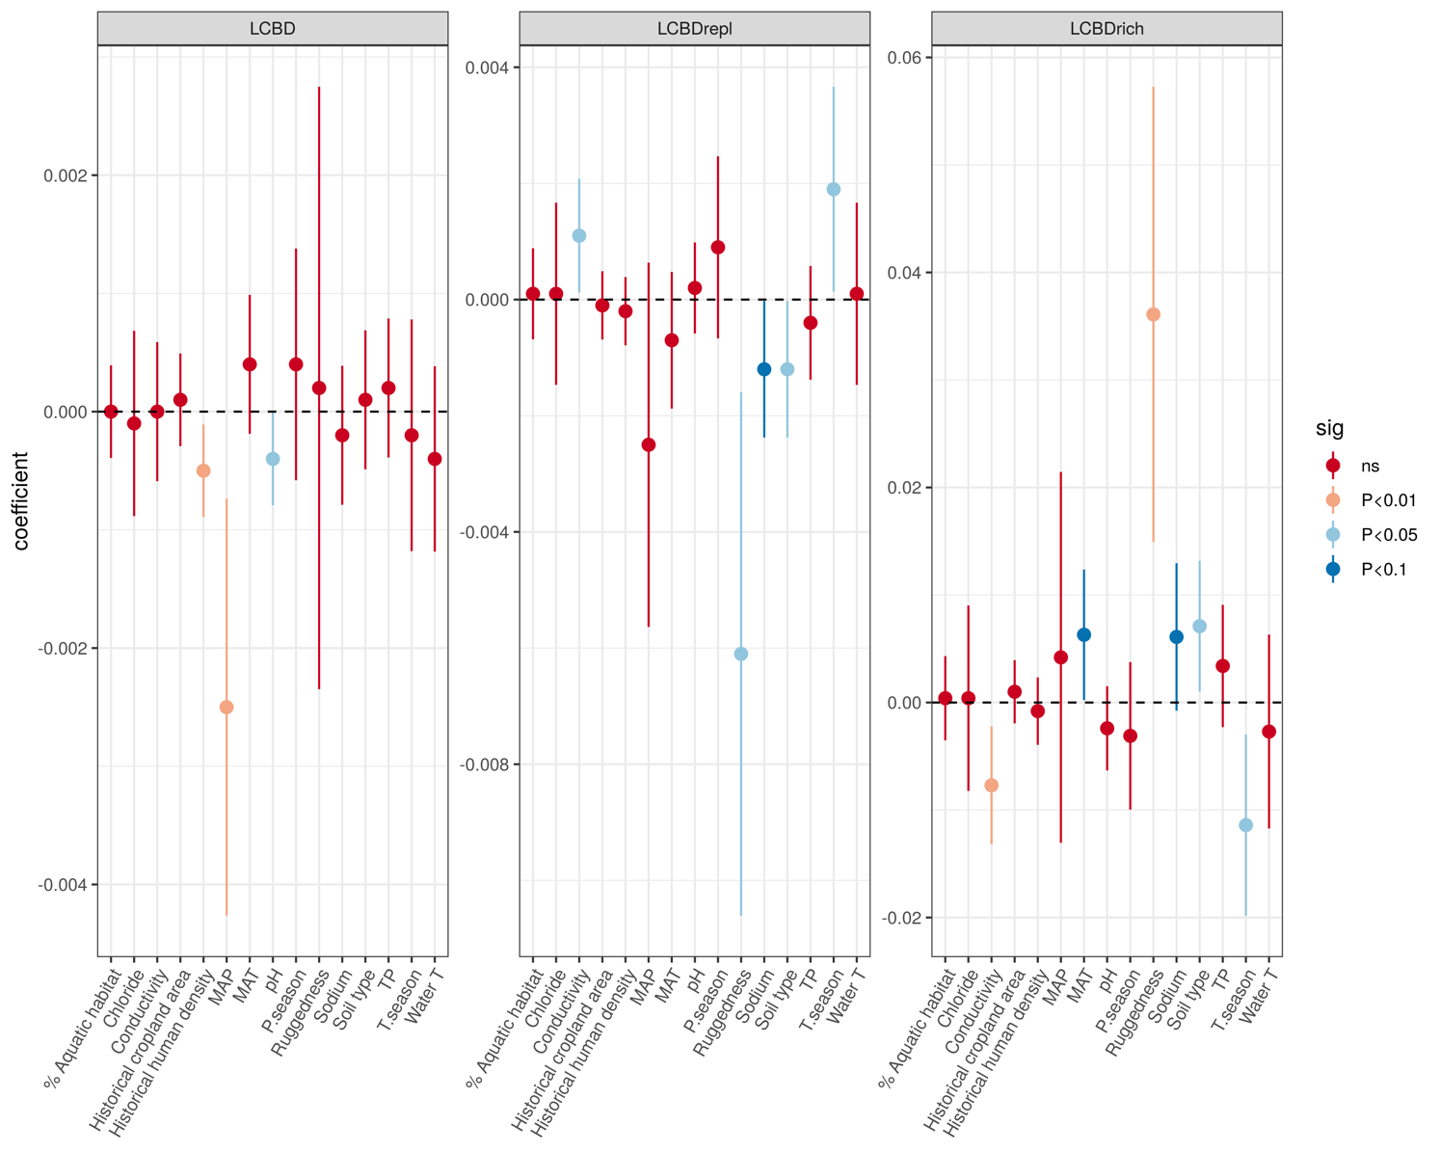

**Figure 2**. Effect of predictors on local contributions to beta diversity (LCBD) components, estimated as linear coefficients from Generalized Additive Models. Errors bars are ± 95% confidence intervals. Colors indicate the significance level α = 0.05.

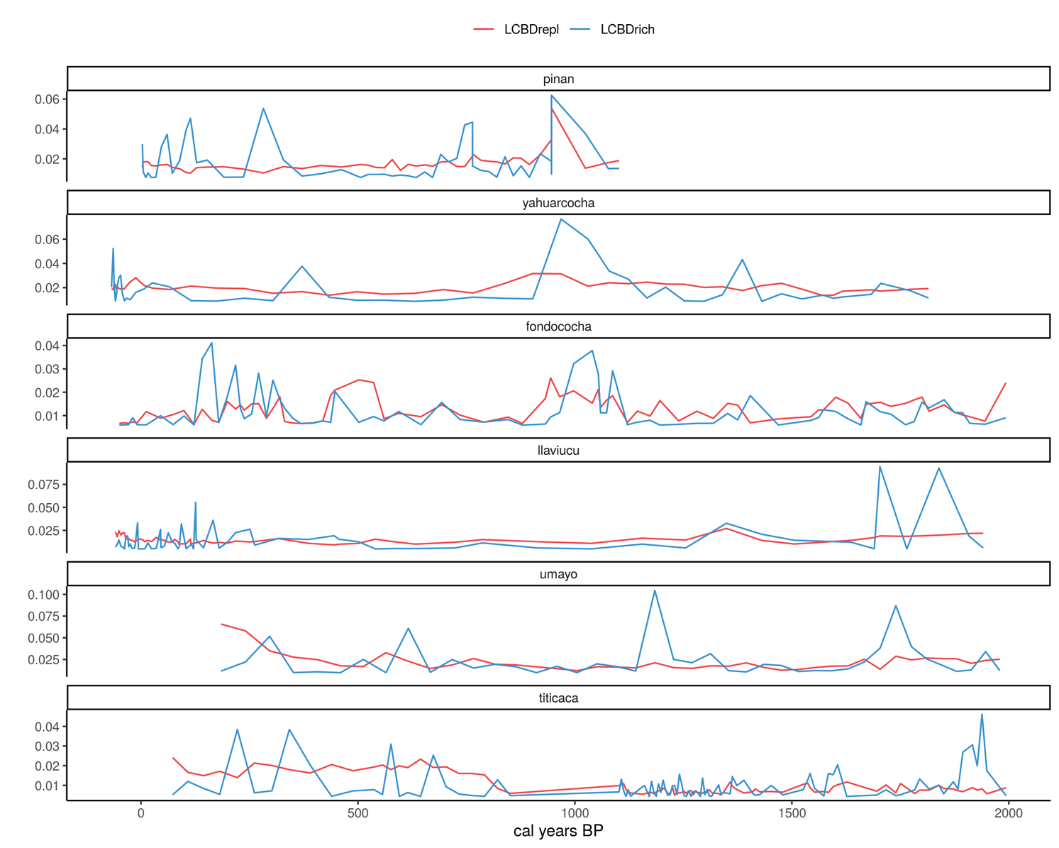

**Figure 3**. Contribution of replacement (LCBDrepl) and richness (LCBDrich) components to beta diversity for the six investigated lake sedimentary sequences (arranged by increased latitude).

**Figure 4**. Temporal trends of beta replacement for the six Andean lakes investigated in this study (arranged by increased latitude). Model GS (green line) indicates a global curve plus inter-lake variation having similar smoothness. Model GI (orange line) indicates a global curve allowing for varied smoothness among lakes.

**Figure 5**. Temporal trends of beta richness for the six Andean lakes investigated in this study (arranged by increased latitude). Model GS (green line) indicates a global curve plus inter-lake variation having similar smoothness. Model GI (orange line) indicates a global curve allowing for varied smoothness among lakes.

**Supplementary material**

SM Figure 1. Lakes with LCBD significant values

# Author Contributions

# Funding

Details of all funding sources should be provided, including grant numbers if applicable. Please ensure to add all necessary funding information, as after publication this is no longer possible.

# Acknowledgments

This is a short text to acknowledge the contributions of specific colleagues, institutions, or agencies that aided the efforts of the authors.

# References

Angeler, David G. 2013. “Revealing a Conservation Challenge through Partitioned Long-Term Beta Diversity: Increasing Turnover and Decreasing Nestedness of Boreal Lake Metacommunities.” *Diversity and Distributions* 19 (7): 772–781.

Anton, Ann. 1987. “Paleolimnology of an Equatorial Lake in the Inter-Andean Plateau of Ecuador.” PhD Thesis, The Ohio State University.

Antonelli, Alexandre, W. Daniel Kissling, Suzette GA Flantua, Mauricio A. Bermúdez, Andreas Mulch, Alexandra N. Muellner-Riehl, Holger Kreft, H. Peter Linder, Catherine Badgley, and Jon Fjelds\a a. 2018. “Geological and Climatic Influences on Mountain Biodiversity.” *Nature Geoscience* 11 (10): 718.

Baker, Paul, and Sherilyn C Fritz. 2015. “Nature and Causes of Quaternary Climate Variation of Tropical South America.” *Quaternary Science Reviews* 124: 31–47. https://doi.org/10.1016/j.quascirev.2015.06.011.

Baselga, Andrés. 2010. “Partitioning the Turnover and Nestedness Components of Beta Diversity.” *Global Ecology and Biogeography* 19 (1): 134–143. https://doi.org/10.1111/j.1466-8238.2009.00490.x.

Battarbee, Richard W., Vivienne J. Jones, Roger J. Flower, Nigel G. Cameron, Helen Bennion, Laurence Carvalho, and Stephen Juggins. 2002. “Diatoms.” In *Tracking Environmental Change Using Lake Sediments*, 155–202. Springer.

Benito, X., and S C Fritz. in press. “Diatom Diversity and Biodiversity across Tropical South America.” In *Neotropical Diversification*, edited by V. Rull and Ana Carolina Carnaval. Springer International Publishing.

Benito, X., S. C. Fritz, M. Steinitz-Kannan, Pedro Tapia, M.A. Kelly, and T.V. Lowell. 2018. “Geo-Climatic Factors Drive Diatom Community Distribution in Tropical South American Freshwaters.” *Journal of Ecology* 106: 1660–72. https://doi.org/10.1111/1365-2745.12934.

Benito, X., S.C. Fritz, M. Steinitz‐Kannan, Maria I. Vélez, and Michael M. McGlue. 2018. “Lake Regionalization and Diatom Metacommunity Structuring in Tropical South America.” *Ecology and Evolution* 8 (16): 7865–78. https://doi.org/10.1002/ece3.4305.

Birks, H. John B., Vivian A. Felde, Anne E. Bjune, John-Arvid Grytnes, Heikki Seppä, and Thomas Giesecke. 2016. “Does Pollen-Assemblage Richness Reflect Floristic Richness? A Review of Recent Developments and Future Challenges.” *Review of Palaeobotany and Palynology* 228: 1–25.

Burnham, KP, and DR Anderson. 2003. *Model Selection and Multimodel Inference: A Practical Information-Theoretic Approach*. Springer. https://books.google.com/books?hl=ca&lr=&id=fT1Iu-h6E-oC&oi=fnd&pg=PR7&dq=Burnham+KP,+Anderson+DR.+Model+selection+and+multimodel+inference:+a+practical+information+–+theoretic+approach.+New+York:+Springer-Verlag%3B+2002+(274+pp.)&ots=tezu8ZSDl8&sig=clKv87681aTzksYy-L2YF1wrH_Y.

Cardinale, Bradley J., J. Emmett Duffy, Andrew Gonzalez, David U. Hooper, Charles Perrings, Patrick Venail, Anita Narwani, Georgina M. Mace, David Tilman, and David A. Wardle. 2012. “Biodiversity Loss and Its Impact on Humanity.” *Nature* 486 (7401): 59–67.

Castro, Emanuela, Tadeu Siqueira, Adriano Sanches Melo, Luis Mauricio Bini, Victor Lemes Landeiro, and Fabiana Schneck. 2019. “Compositional Uniqueness of Diatoms and Insects in Subtropical Streams Is Weakly Correlated with Riffle Position and Environmental Uniqueness.” *Hydrobiologia* 842 (1): 219–232.

Catalan, Jordi, and John C. Donato Rondón. 2016. “Perspectives for an Integrated Understanding of Tropical and Temperate High-Mountain Lakes.” *Journal of Limnology* 75: 215–34.

Colinvaux, Paul A., Mark B. Bush, Miriam Steinitz-Kannan, and Michael C. Miller. 1997. “Glacial and Postglacial Pollen Records from the Ecuadorian Andes and Amazon.” *Quaternary Research* 48 (1): 69–78.

Dornelas, Maria, Nicholas J. Gotelli, Brian McGill, Hideyasu Shimadzu, Faye Moyes, Caya Sievers, and Anne E. Magurran. 2014. “Assemblage Time Series Reveal Biodiversity Change but Not Systematic Loss.” *Science* 344 (6181): 296–299.

Dray, S., G. Blanchet, D. Borcard, G. Guenard, T. Jombart, G. Larocque, P. Legendre, and H. H. Wagner. 2016. *Adespatial: Multivariate Multiscale Spatial Analysis. R Package Version 0.0-4*.

Ekdahl, Erik J., Sherilyn C. Fritz, Paul A. Baker, Catherine A. Rigsby, and Kirstin Coley. 2008. “Holocene Multidecadal-to Millennial-Scale Hydrologic Variability on the South American Altiplano.” *The Holocene* 18 (6): 867–876.

Fritz, S. C., P. A. Baker, P. Tapia, T. Spanbauer, and K. Westover. 2012. “Evolution of the Lake Titicaca Basin and Its Diatom Flora over the Last ∼370,000 Years.” *Palaeogeography, Palaeoclimatology, Palaeoecology* 317–318: 93–103. https://doi.org/10.1016/j.palaeo.2011.12.013.

Gayo, Eugenia M., Claudio Latorre, and Calogero M. Santoro. 2015. “Timing of Occupation and Regional Settlement Patterns Revealed by Time-Series Analyses of an Archaeological Radiocarbon Database for the South-Central Andes (16–25 S).” *Quaternary International* 356: 4–14.

Goldberg, Amy, Alexis M. Mychajliw, and Elizabeth A. Hadly. 2016. “Post-Invasion Demography of Prehistoric Humans in South America.” *Nature* 532 (7598): 232.

Goldewijk, Kees Klein, Arthur Beusen, Gerard van Drecht, and Martine de Vos. 2011. “The HYDE 3.1 Spatially Explicit Database of Human-Induced Global Land-Use Change over the Past 12,000 Years.” *Global Ecology and Biogeography* 20 (1): 73–86. https://doi.org/10.1111/j.1466-8238.2010.00587.x.

Gregory-Eaves, I., and Beatrix E. Beisner. 2011. “Palaeolimnological Insights for Biodiversity Science: An Emerging Field.” *Freshwater Biology* 56 (12): 2653–2661.

Guiry, M. D., and G. M. Guiry. 2017. *AlgaeBase. World-Wide Electronic Publication, National University of Ireland, Galway*.

Heino, Jani. 2013. “The Importance of Metacommunity Ecology for Environmental Assessment Research in the Freshwater Realm.” *Biological Reviews* 88 (1): 166–178. https://doi.org/10.1111/j.1469-185X.2012.00244.x.

Heino, Jani, Janne Soininen, Janne Alahuhta, Jyrki Lappalainen, and Risto Virtanen. 2016. “Metacommunity Ecology Meets Biogeography: Effects of Geographical Region, Spatial Dynamics and Environmental Filtering on Community Structure in Aquatic Organisms.” *Oecologia* 183: 121–137. https://doi.org/10.1007/s00442-016-3750-y.

Hijmans, Robert J., Susan E. Cameron, Juan L. Parra, Peter G. Jones, and Andy Jarvis. 2005. “Very High Resolution Interpolated Climate Surfaces for Global Land Areas.” *International Journal of Climatology* 25 (15): 1965–1978. https://doi.org/10.1002/joc.1276.

Jarvis, Andy, Hannes Isaak Reuter, Andrew Nelson, Edward Guevara, and others. 2008. “Hole-Filled SRTM for the Globe Version 4.” *Available from the CGIAR-CSI SRTM 90m Database (Http://Srtm. Csi. Cgiar. Org)*. http://www.cgiar-csi.org/data/srtm-90m-digital-elevation-database-v4-1.

Jyrkänkallio-Mikkola, Jenny, Mika Siljander, Vuokko Heikinheimo, Petri Pellikka, and Janne Soininen. 2018. “Tropical Stream Diatom Communities – The Importance of Headwater Streams for Regional Diversity.” *Ecological Indicators* 95 (December): 183–93. https://doi.org/10.1016/j.ecolind.2018.07.030.

Kärnä, Olli-Matti, Jani Heino, Mira Grönroos, and Jan Hjort. 2018. “The Added Value of Geodiversity Indices in Explaining Variation of Stream Macroinvertebrate Diversity.” *Ecological Indicators* 94 (November): 420–29. https://doi.org/10.1016/j.ecolind.2018.06.034.

Kristiansen, Jørgen. 1996. “16. Dispersal of Freshwater Algae—a Review.” *Hydrobiologia* 336 (1–3): 151–157.

Legendre, Pierre. 2014. “Interpreting the Replacement and Richness Difference Components of Beta Diversity.” *Global Ecology and Biogeography* 23 (11): 1324–1334.

Lehner, Bernhard, and Petra Döll. 2004. “Development and Validation of a Global Database of Lakes, Reservoirs and Wetlands.” *Journal of Hydrology* 296 (1–4): 1–22. https://doi.org/10.1016/j.jhydrol.2004.03.028.

Leibold, M. A., M. Holyoak, N. Mouquet, P. Amarasekare, J. M. Chase, M. F. Hoopes, R. D. Holt, et al. 2004. “The Metacommunity Concept: A Framework for Multi-Scale Community Ecology.” *Ecology Letters* 7 (7): 601–613. https://doi.org/10.1111/j.1461-0248.2004.00608.x.

McGill, Brian J., Maria Dornelas, Nicholas J. Gotelli, and Anne E. Magurran. 2015. “Fifteen Forms of Biodiversity Trend in the Anthropocene.” *Trends in Ecology & Evolution* 30 (2): 104–113.

Monchamp, Marie-Eve, Piet Spaak, Isabelle Domaizon, Nathalie Dubois, Damien Bouffard, and Francesco Pomati. 2018. “Homogenization of Lake Cyanobacterial Communities over a Century of Climate Change and Eutrophication.” *Nature Ecology & Evolution* 2 (2): 317.

Moser, K. A., J. S. Baron, J. Brahney, I. A. Oleksy, J. E. Saros, E. J. Hundey, S. A. Sadro, et al. 2019. “Mountain Lakes: Eyes on Global Environmental Change.” *Global and Planetary Change* 178 (April): 77–95. https://doi.org/10.1016/j.gloplacha.2019.04.001.

Mouquet, Nicolas, Dominique Gravel, François Massol, and Vincent Calcagno. 2013. “Extending the Concept of Keystone Species to Communities and Ecosystems.” *Ecology Letters* 16 (1): 1–8.

Myers, Norman, Russell A Mittermeier, Cristina G Mittermeier, Gustavo A B Da Fonseca, and Jennifer Kent. 2000. “Biodiversity Hotspots for Conservation Priorities.” *Nature* 403 (24): 853–858.

Novaes Nascimento, Majoi de, Anne Gail Laurenzi, Bryan G Valencia, Robert Van, and Mark Bush. 2018. “A 12,700-Year History of Paleolimnological Change from an Andean Microrefugium.” *The Holocene*, November, 0959683618810400. https://doi.org/10.1177/0959683618810400.

Olden, Julian D., N. LeRoy Poff, Marlis R. Douglas, Michael E. Douglas, and Kurt D. Fausch. 2004. “Ecological and Evolutionary Consequences of Biotic Homogenization.” *Trends in Ecology & Evolution* 19 (1): 18–24.

Olden, Julian D., and Thomas P. Rooney. 2006. “On Defining and Quantifying Biotic Homogenization.” *Global Ecology and Biogeography* 15 (2): 113–20. https://doi.org/10.1111/j.1466-822X.2006.00214.x.

PAGES 2k Consortium. 2013. “Continental-Scale Temperature Variability during the Past Two Millennia.” *Nature Geoscience* 6 (5): 339–46. https://doi.org/10.1038/ngeo1797.

Passy, Sophia I. 2010. “A Distinct Latitudinal Gradient of Diatom Diversity Is Linked to Resource Supply.” *Ecology* 91 (1): 36–41.

Pedersen, Eric J., David L. Miller, Gavin L. Simpson, and Noam Ross. 2019. “Hierarchical Generalized Additive Models in Ecology: An Introduction with Mgcv.” *PeerJ* 7: e6876.

Pla-Rabés, Sergi, and Jordi Catalan. 2018. “Diatom Species Variation between Lake Habitats: Implications for Interpretation of Paleolimnological Records.” *Journal of Paleolimnology*, 1–19.

Podani, János, Carlo Ricotta, and Dénes Schmera. 2013. “A General Framework for Analyzing Beta Diversity, Nestedness and Related Community-Level Phenomena Based on Abundance Data.” *Ecological Complexity* 15: 52–61.

R Development Team. 2016. *R: A Language and Environment for Statistical Computing*. Vienna, Austria.

Ruhí, Albert, Thibault Datry, and John L. Sabo. 2017. “Interpreting Beta-Diversity Components over Time to Conserve Metacommunities in Highly Dynamic Ecosystems.” *Conservation Biology* 31 (6): 1459–1468.

Sarmiento, Fausto O. 2002. “Anthropogenic Change in the Landscapes of Highland Ecuador.” *Geographical Review* 92 (2): 213–234.

Simpson, Gavin L. 2018. “Modelling Palaeoecological Time Series Using Generalised Additive Models.” *Frontiers in Ecology and Evolution* 6: 149.

Smol, John P., and Eugene F. Stoermer. 2010. *The Diatoms: Applications for the Environmental and Earth Sciences*. Cambridge University Press.

Soininen, Janne, Jani Heino, and Jianjun Wang. 2018. “A Meta-Analysis of Nestedness and Turnover Components of Beta Diversity across Organisms and Ecosystems.” *Global Ecology and Biogeography* 27 (1): 96–109.

Spanbauer, Trisha L., S. C. Fritz, and P. A. Baker. 2018. “Punctuated Changes in the Morphology of an Endemic Diatom from Lake Titicaca.” *Paleobiology* 44: 89–100. https://doi.org/10.1017/pab.2017.27.

Steffen, Will, Jacques Grinevald, Paul Crutzen, and John McNeill. 2011. “The Anthropocene: Conceptual and Historical Perspectives.” *Philosophical Transactions of the Royal Society A: Mathematical, Physical and Engineering Sciences* 369 (1938): 842–867.

Steinitz-Kannan, M., P. Colinvaux, and R. Kannan. 1983. “Limnological Studies in Ecuador: 1. A Survey of Chemical and Physical Properties of Ecuadorian Lakes.” *Arch. Hydrobiol* 65 (1): 61–105.

Szabó, Beáta, Edina Lengyel, Judit Padisák, and Csilla Stenger-Kovács. 2019. “Benthic Diatom Metacommunity across Small Freshwater Lakes: Driving Mechanisms, β-Diversity and Ecological Uniqueness.” *Hydrobiologia* 828 (1): 183–98. https://doi.org/10.1007/s10750-018-3811-9.

Toivanen, Maija, Jan Hjort, Jani Heino, Helena Tukiainen, Jukka Aroviita, and Janne Alahuhta. 2019. “Is Catchment Geodiversity a Useful Surrogate of Aquatic Plant Species Richness?” *Journal of Biogeography* 46 (8): 1711–22. https://doi.org/10.1111/jbi.13648.

Valencia, Bryan G., Frazer Matthews-Bird, Dunia H. Urrego, Joseph J. Williams, William D. Gosling, and Mark Bush. 2016. “Andean Microrefugia: Testing the Holocene to Predict the Anthropocene.” *New Phytologist* 212 (2): 510–522. https://doi.org/10.1111/nph.14042.

Van Dam, Herman, Adrienne Mertens, and Jos Sinkeldam. 1994. “A Coded Checklist and Ecological Indicator Values of Freshwater Diatoms from the Netherlands.” *Netherland Journal of Aquatic Ecology* 28 (1): 117–133.

Velghe, Katherine, Jesse C. Vermaire, and Irene Gregory‐Eaves. 2012. “Declines in Littoral Species Richness across Both Spatial and Temporal Nutrient Gradients: A Palaeolimnological Study of Two Taxonomic Groups.” *Freshwater Biology* 57 (11): 2378–89. https://doi.org/10.1111/fwb.12017.

Vilmi, Annika, Satu Maaria Karjalainen, and Jani Heino. 2017. “Ecological Uniqueness of Stream and Lake Diatom Communities Shows Different Macroecological Patterns.” *Diversity and Distributions* 23 (9): 1042–1053.

Weide, D. Marie, Sherilyn C. Fritz, Christine A. Hastorf, Maria C. Bruno, Paul A. Baker, Stephane Guedron, and Wout Salenbien. 2017. “A∼ 6000 Yr Diatom Record of Mid-to Late Holocene Fluctuations in the Level of Lago Wiñaymarca, Lake Titicaca (Peru/Bolivia).” *Quaternary Research* 88 (2): 179–192.

Wengrat, Simone, Andre A. Padial, Erik Jeppesen, Thomas A. Davidson, Luciane Fontana, Sandra Costa-Böddeker, and Denise C. Bicudo. 2018. “Paleolimnological Records Reveal Biotic Homogenization Driven by Eutrophication in Tropical Reservoirs.” *Journal of Paleolimnology* 60 (2): 299–309. https://doi.org/10.1007/s10933-017-9997-4.

Willis, K. J., R. M. Bailey, S. A. Bhagwat, and H. J. B. Birks. 2010. “Biodiversity Baselines, Thresholds and Resilience: Testing Predictions and Assumptions Using Palaeoecological Data.” *Trends in Ecology & Evolution* 25 (10): 583–591.

Winegardner, Amanda K., Pierre Legendre, Beatrix E. Beisner, and Irene Gregory-Eaves. 2017. “Diatom Diversity Patterns over the Past c. 150 Years across the Conterminous United States of America: Identifying Mechanisms behind Beta Diversity.” *Global Ecology and Biogeography* 26 (11): 1303–1315.

Wood, Simon N. 2011. “Fast Stable Restricted Maximum Likelihood and Marginal Likelihood Estimation of Semiparametric Generalized Linear Models.” *Journal of the Royal Statistical Society: Series B (Statistical Methodology)* 73 (1): 3–36.

———. 2017. *Generalized Additive Models: An Introduction with R*. CRC press.

# Supplementary Material

Supplementary Material should be uploaded separately on submission, if there are Supplementary Figures, please include the caption in the same file as the figure. Supplementary Material templates can be found in the Frontiers Word Templates file.

Please see the [Supplementary Material section of the Author guidelines](http://home.frontiersin.org/about/author-guidelines#SupplementaryMaterial) for details on the different file types accepted.

# Data Availability Statement

Diatom and environmental datasets, and R code to perform the analyses are available from GitHub (https://github.com/xbenitogranell/XXX).